Project Design Phase
Solution Architecture

Date | 18 June 2026
Team ID
Project Name | SHOPEZ : E-Commerce Application
Maximum Marks | 4 Marks

Solution Architecture:
The solution architecture of SHOPEZ is designed to provide a secure, scalable, and user-friendly e-commerce platform that enables customers to browse products, manage shopping carts, place orders, and track purchases efficiently. The architecture bridges the gap between customer requirements and technology by integrating modern web technologies through the MERN stack (MongoDB, Express.js, React.js, and Node.js).
The architecture follows a three-tier structure consisting of the presentation layer, application layer, and database layer. The presentation layer is developed using React.js, providing an interactive and responsive user interface. The application layer is implemented using Node.js and Express.js, which handle business logic, user authentication, product management, and order processing. MongoDB serves as the database layer, storing user information, product details, shopping cart data, and order records.
The system supports multiple modules such as user registration and login, product browsing, search and filtering, shopping cart management, order placement, order tracking, and administrative management. Secure authentication mechanisms ensure that user data and transactions remain protected.
The solution architecture is designed to achieve the following objectives:

1. Efficient Product Management
The system allows administrators to add, update, delete, and manage products efficiently while maintaining accurate inventory information.

2. Secure User Authentication
Users can securely register and log in using authentication mechanisms that protect personal information and ensure authorized access.

3. Seamless Shopping Experience
Customers can browse products, search for items, add products to their shopping cart, and complete purchases through a simple and intuitive interface.

4. Reliable Order Processing
The application processes customer orders efficiently and provides order tracking capabilities, allowing users to monitor the status of their purchases.
5. Scalable and Maintainable Design
The MERN stack architecture enables future enhancements such as payment gateway integration, recommendation systems, mobile application support, cloud deployment, and multi-vendor functionality.

6. Improved Customer Satisfaction
By offering a responsive design, fast product access, secure transactions, and real-time order management, the system improves overall customer satisfaction and shopping convenience.

Development Technologies Used
- Frontend: React.js, HTML, CSS, JavaScript
- Backend: Node.js, Express.js
- Database: MongoDB
- Authentication: JWT Authentication
- API Communication: REST APIs

Conclusion
The SHOPEZ solution architecture provides a robust foundation for an online shopping platform by combining modern web technologies, secure user management, efficient product handling, and scalable system design. This architecture ensures high performance, reliability, and a smooth shopping experience for customers while supporting future growth and enhancements.
Example - SHOPEZ : E-Commerce Application Solution Architecture Diagram:
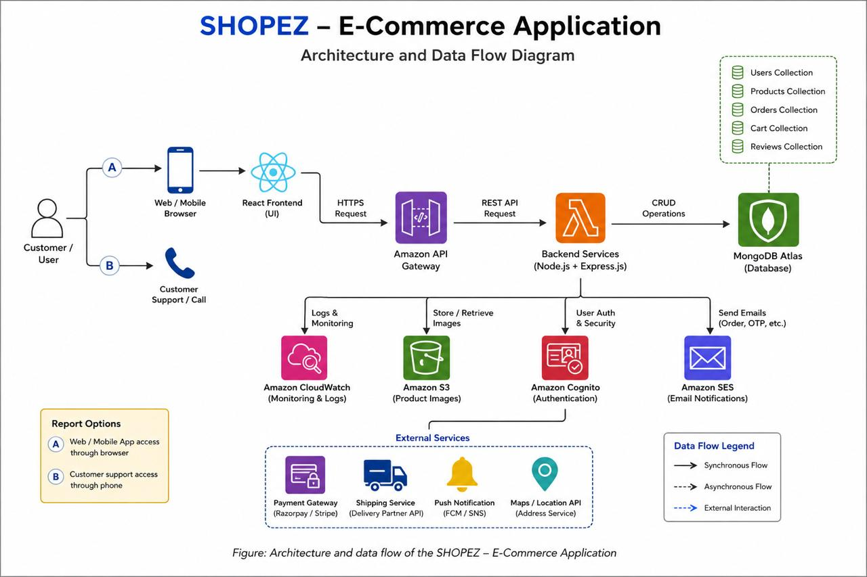Figure 1: Architecture and data flow of the voice patient diary sample application
Reference: https://aws.amazon.com/blogs/industries/voice-applications-in-clinical-research-powered-by-ai-on-aws-part-1-architecture-and-design-considerations/

